**PRESS RELEASE**

**No. 36 / August 2018**

**The Government of Mexico recognizes 31 "Mexicanos Distinguidos" living abroad**

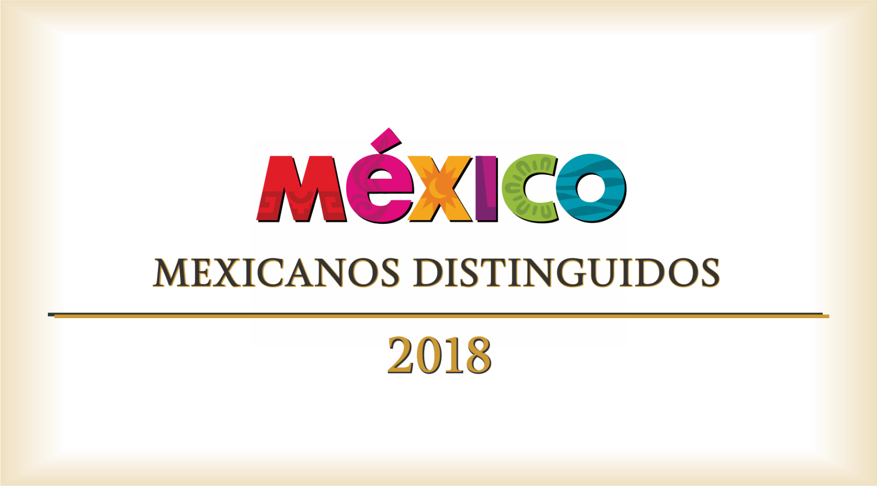

The **Consulate of Mexico in Del Rio** informs that ***The Institute of Mexicans Abroad (IME)***, the ***National Institute of Women (INMUJERES)*** and the ***Coordination of Country Brand and International Media of the Presidency of the Republic*** announce the grant of **‘Mexicanos Distinguidos’ Recognition** to 31 Mexicans living abroad, whom are distinguished by having an outstanding career in their professional field. This new recognition has the objective of highlight the extraordinary career, as well as the human and professional quality of the Mexican people residing abroad, who from their new places of residence continue to promote our country.

On July 30th , the first session of the Evaluation Committee was held to award the newly created "Mexicanos Distinguidos" Recognition. The IME submitted 49 candidatures to the Committee, which were sent by the Representations of Mexico Abroad. Although the Call had contemplated 30 recognitions, the Evaluation Committee recommended granting 31 awards, due to the high quality of the profiles of the candidates.

The Committee is integrated by the Ambassador Juan Carlos Mendoza Sánchez, Director of IME, Ambassador Pedro González Olvera, Head of the Fernando Solana Chair, Dr. Luis de la Calle Pardo, Vice President of the Mexican Council of International Affairs (COMEXI), Marcela Eternod Arámburu, Executive Secretary of INMUJERES, as well as representatives of the Coordination of Country Brand and International Media.

The winners reside in all regions of the world: America, Europe, Africa and Asia. Among the Mexicans receiving the award are established figures in their fields such as the dancer Isaac Hernández, the conductor Enrique Diemecke, the chef Lydia González Aguilar, the architect Enrique Norten and the violinist Paulina Derbez. The areas of expertise of the winners are diverse: science and academia, entrepreneurship and innovation, creative industries, entrepreneurs, doctors, musicians and restaurateurs, among others. The common denominator of the people distinguished with this award is their professional excellence and their commitment to Mexico.

The 31 selected people will receive this recognition, which consists of a silver medal coined especially by the ‘Casa de Moneda’ for this award, in the coming months through the Embassies and Consulates that nominated them.

In that regard, the Consulate of Mexico in Del Rio is pleased to announce that the artist Adrián Jesús Falcón has been one of the 31 Mexicans awarded with this recognition by the Mexican Government.

His great career in the field of visual arts has led him to exhibit his works in the United States, Mexico, Russia and in European countries such as Italy and France.

His work, which has been published by international art magazines, and his dedication to providing art classes to children of indigenous communities in Mexico, while painting murals in their schools (absorbing the costs of materials and labor), have made him earn this well-deserved recognition.

Congrats to all the winners:

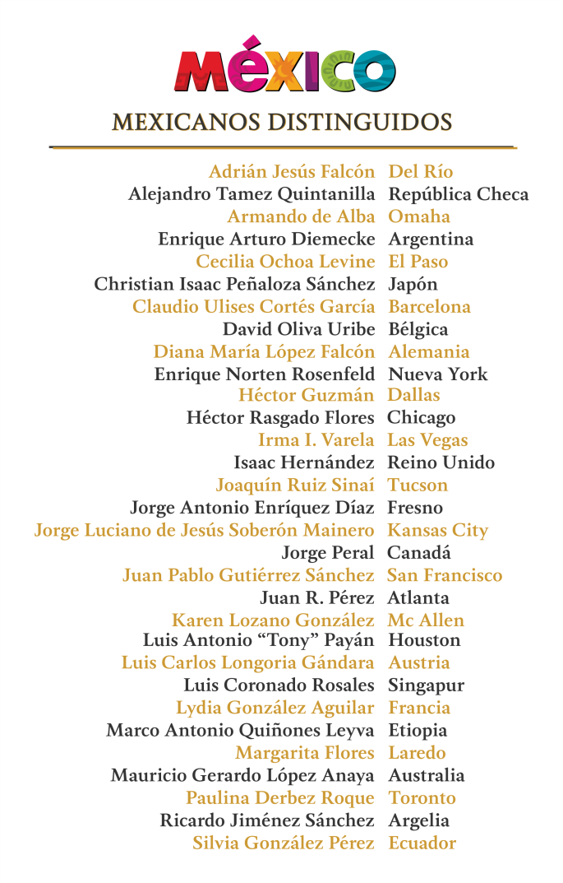

**Consulado de México en Del Rio**

@ConsulMexDelRio

2207 North Bedell Ave.  
Tel: (830) 775-2352  
Email: condrio@sre.gob.mx

/ConsulMexDelRio

CIAM Firma